St Thomas the Apostle College A Level Course Guide  A-level French  Introduction  It is now generally accepted that fluency in at least one foreign language is an essential asset in many areas of working life. In many job sectors, the mastery of a foreign language is a key component. A French course in our Sixth Form is clearly important for those who wish to specialise in languages, but is also an ideal complement to both Humanities and Science courses, as well as Economics and Law.  This course will expose students to some of the best of what has ever been written (French writers and philosophers and widely regarded as being some of the most influential in the world!) This A-Level not only enhances your employability and earning potential but also it makes you more adaptable and culturally aware!  Furthermore, studying A-Level French is not just about learning a language; it is a choice that enriches your cultural knowledge, strengthens your academic profile, and opens up diverse career opportunities worldwide.  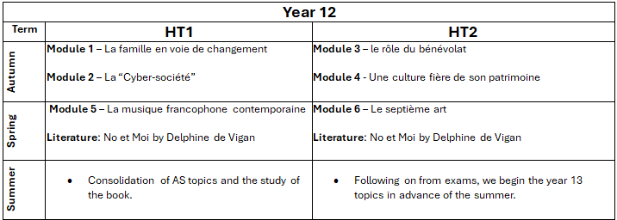  Topics:  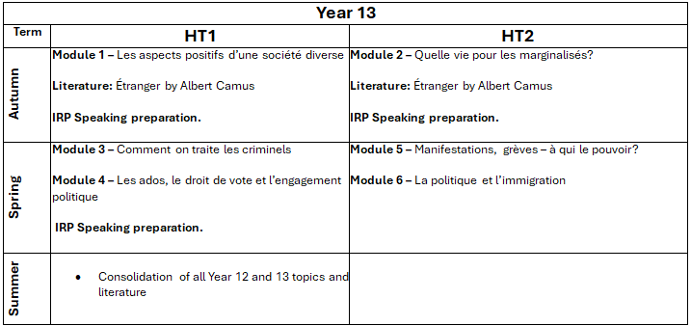 |  | 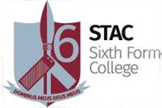  Assessment:  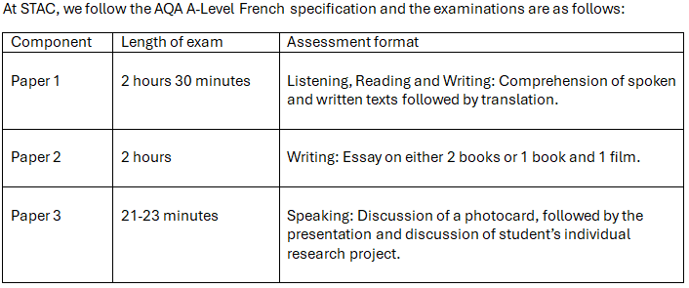  Career Progression  A language on your CV greatly appeals to employers: it shows that you have determination and are not put off by a challenge. This will set you apart from other candidates. Employers will consider you as a real asset in their workforce. Studying a language opens doors which remain closed to other people: not only will your career options be significantly better, but you will also have a wider understanding of other cultures and world affairs. Careers which require a language range from education, international law, counselling, social services, customer services, sales, marketing, international trade, translator, interpreter, language teacher and linguist.  Entry Requirements  Grade 7 in GCSE French.

